Name

**UrRobot Programming Exercises – From Chapter 2 KarelJ Robot Book by Joe Bergin**

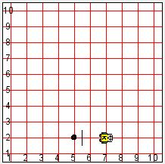

1. Start a UrRobot facing EAST at the location shown in the picture. This robot's task is to pick the beeper and return it to its starting location and put the beeper down.

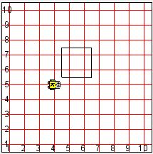

2. Start a UrRobot facing EAST at the location shown in the picture. This UrRobot's task is to walk around the box of beepers and return to its starting location.

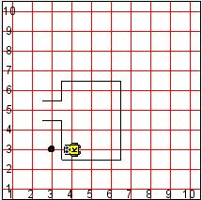 3. Every morning your UrRobot is awakened in bed when the newspaper, represented by a beeper, is thrown on the front porch of the house (represented by nets). Program your UrRobot to retrieve the paper and bring it back to bed. Start your UrRobot as shown in the picture. When your program ends, your UrRobot should be back where it started and should put the beeper in the robot's ending location.

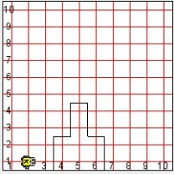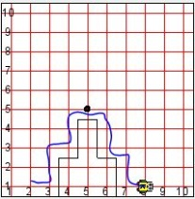

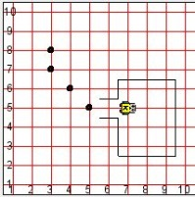 4. Program your UrRobot to climb the mountain of beepers and place a flag (a beeper) at the summit. Remember to start your UrRobot with a beeper in its pouch at the location and in the direction shown in the picture. Your UrRobot should climb down the mountain and end at the bottom of the mountain on the opposite side of where it started, facing EAST.

5. On the way home from the supermarket, your robot's shopping bag ripped slightly at the bottom, leaking some expensive beepers. The

initial condition is shown here. Program your UrRobot to pick up all of the

beepers and then return to its starting position.

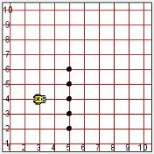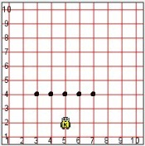

6. Write a program that instructs your UrRobot to rearrange the beepers as shown. Do this as efficiently as possible.

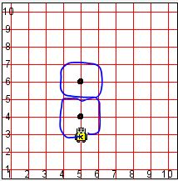 7. Your UrRobot is practicing for the Robot Winter Olympics. One of the events is shuttle racing. This race requires a UrRobot to move around two beepers in a figure 8 pattern as shown. Write a program that instructs your UrRobot to move in the pattern as fast (fewest lines of code) as possible. Your UrRobot must end in the same place it started and must be facing the same direction.